THE TITLE OF THE PAPER, TIMES NEW ROMAN, 14,
IN BOLD CAPITAL LETTERS, CENTRED – spacing before:162p; spacing after: 30pt
Names of the Authors, upper and lower case,
Times New Roman, Bold, 11, centred – spacing after: 30pt
Authors’ affiliations, Times New Roman, Italic, Italics, 11,
upper and lower case, centre– spacing after: 30pt
Abstract: Abstract of 50–100 words, 140 mm width (maximum), justified Times New Roman, Italic, 10, centred; Indentation: Left 1 cm, Right 1 cmxx– spacing after: 6pt
Keywords: 5–10 keywords, 140 mm width, left justified; – spacing after: 42pt

1. MAIN HEADING, BOLD, CENTRED, CAPITAL LETTERS, FOLLOWING LINES INDENTED
↵
Text of paper, 76 mm column width, with 8 mm space between, use Times Roman font, 11 point.
↵
Paragraphs should be justified, using single spacing, with no paragraph indentation. Leave one clear line between paragraphs within a section; two clear lines before a main or secondary heading; one clear line before a tertiary heading.
↵
↵
1.1 Secondary Heading, left justified, following lines indented, Italics, bold .
↵
1.1.1 Tertiary Heading; Italics, numbered, left justified
↵
Avoid leaving a heading at the bottom of a column, with the subsequent text starting at the top of the next page/column. Use extra spacing (between earlier sections) to push the heading up to the top of the same column as its text. In view of the tight page constraints, however, do make the fullest possible use of text area.
↵
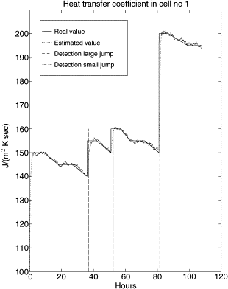
↵
Fig. X. Title of figure, centred, 10p Times New Roman.
↵
Equations are left justified and numbered consecutively, from 1 (n)
↵
Table X: Heading left justified. 10p Times New Roman.
↵
REFERENCES
↵
List of references arranged alphabetically according to first author, subsequent lines indented. Publications by the same author(s) should be listed in order of year of publication

[1] Nosrati, R., Fonteix, C., Recents progres en genie des procedees, Ed. Lavoisier, France, p.275,1991.

Remarks :
--- In the PDF version, the character “↵” is used to represent a space equivalent to one line of text.
--- Place figures at the top or bottom of a column wherever possible, as close as possible to the first references to them in the paper. Restrict them to single-column width unless this would make them illegible. Coloured photographs or figures will not be reproduced in colour.
--- Please insert the presented header to be modified specifically

